|  |  |
| --- | --- |
| **A Life Insurance Claim Process Transformation**  A BPMN Report | Abstract  This is a BPMN project report that examines and redesigns a branch-level life insurance claims processes. The analysis revealed inefficiencies and manual bottlenecks in a the current processes that hinders customer experience. A new, process that heavily relied on a claim management system embedded with consolidated key national database was proposed to streamline operations, eliminate waste, and enhance both efficiency and customer experience.  Kwasi Marfo  MSc. Statistics and Information Management with Specialization in Risk Analysis and Management. |

Executive Summary 2

Project Objective 2

A BPMN Analysis of A Branch Level Life Insurance Company 3

Overview of the Current Claims Process (AS-IS) 3

OBSERVED PAIN POINTS & RISK AREAS 5

AS-IS PROCESS ANALYSIS 5

Qualitative Analysis 5

Quantitative Analysis 7

Key Results of the AS-IS Claim Process 9

REDESIGNING 12

Task Elimination (Heuristic 1) 12

Task Composition and Decomposition (Heuristic 2) 13

Triage (Heuristic 3) 13

Re-sequencing (Heuristic 4) 13

Parallelism Enhancement (Heuristic 5) 13

Process Specialization (Heuristic 6) 14

Resource Optimization (Heuristic 7) 14

Communication Optimization (Heuristic 8) 14

Automation (Heuristic 9) 14

Overview of the TO-BE Claims Process 15

Automated Submission 15

Claims Underwriting 16

Approval 18

ANALYSIS OF THE TO-BE MODEL 19

Assumption 19

Key Results of the TO-BE Claim Process 21

Overall Process Performance 21

Cost Analysis 21

Execution Time Analysis 22

Resource Utilization 22

Bottlenecks and Process Insights 23

Comparison: TO-BE vs AS-IS 23

Automation 23

Workload Distribution 23

Claimant Experience 23

Decision Efficiency 23

Process Transparency 23

CONCLUSION 24

# Executive Summary

## Project Objective

This project aimed to improve the efficiency, speed, and customer experience of the claims processes at a branch-level life insurance company. Management observed that periodically an claim officers were overwhelmed leading to backlogs of pending claim requests. This suggested a structural bottlenecks. The goal was to identify and eliminate the inefficiencies and enhance the company’s ability to meet its 24-hour claims settlement promise.

### Why Change Was Necessary?

An in-depth review of the existing ("AS-IS") claims process revealed several recurring issues:

* Claims officers were handling 98% of all tasks, leading to frequent delays.
* Manual verification and investigations slowed down turnaround time.
* Customers experienced poor communication and delays in claim resolution.
* Investigations, which should be exceptions, caused the biggest delays and costs.

These issues were not due to lack of staff or funds, but rather an excessive manual step.

### What Was Done?

A new process ("TO-BE") was developed using process improvement techniques and business process simulation. The redesigned process introduced:

* A **centralized Claims Management System (CMS)** integrated with national databases (Health Service Database, Police Database, National Investigation Authority (NIA), Birth and Death, etc.).
* **Automation** of claim submission, verification, and approvals.
* **Smart triaging** to fast-track low-value claims and prioritize complex ones.
* **Real-time SMS/email updates** to keep customers informed throughout the process.
* **Redistribution of workload** to reduce dependency on a few officers.

### Key Results of the New Process

|  |  |  |  |
| --- | --- | --- | --- |
| **Metric** | **AS-IS (Old Process)** | **TO-BE (New Process)** | **% Improvement** |
| Average Claim Processing Time | 5.33 days | 0.20 days | **96% faster** |
| Total Cost (20 cases) | GHC1,318.85 | GHC221.30 | **84% lower** |
| Claims Officer Workload | 2.66 days | 0.08 days | **88% lighter** |

# A BPMN Analysis of A Branch Level Life Insurance Company

This report presents the findings of a business process improvement initiative conducted on the claims process of a branch-level life insurance company. The primary objective of the project was to significantly reduce the turnaround times, eliminate of avoidable delays, and to enhance the overall customer experience.

The company maintains a strategic commitment to operational excellence in customer experience. It promises to pay valid claims within 24hrs. Thhe project involved a comprehensive analysis of the existing claims processes. Key inefficiencies were identified, redesigned, and more streamlined process was proposed to improve responsiveness and service quality.

To contextualize the process analysis, the following general assumptions were made about the operating environment of the company:

* The company operates as a life insurance provider, offering policies that cover death, critical illness, accidents, and disability.
* It is based in Ghana. Ghana has quality national database for various public institutions, including those from the National Identification Authority, Ghana Health Service, Birth and Death Registry and The Police Service
* The insurer has the technical and legal capacity to access these databases to support claim validation and fraud prevention efforts.

These assumptions guided the redesign and simulation efforts. The analysis was conducted using Business Process Model and Notation (BPMN) principles, supported by SAP Signavio process manager for modeling and simulation. This was further complemented by a review of internal performance data to validate the feasibility and potential impact of the proposed improvements.

# Overview of the Current Claims Process (AS-IS)

The current life insurance claims process consists of six key stages, beginning with the submission of a claim and ending with either the payment or repudiation of benefits. These stages are as follows:

1. **Claim Submission:** The process begins when the claimant submits a completed claims form along with all required supporting documents, such as a valid ID, medical records, or a death certificate. Submissions can be made either online or in person at the branch.
2. **Verification**: A claims officer conducts a preliminary check to ensure that the submitted documentation is complete. This step also involves verifying the identities of both the claimant and the insured person, as well as confirming that the policy in question is active and in force.
3. **Claims Assessment:** (Referred to as Claim Underwriting) The claims officers reviews the submitted claim to determine whether the benefit is payable under the terms of the policy. This includes verifying that all premiums have been paid and confirming that the cause of the claim (e.g., death, illness, or injury) falls within the scope of coverage.
4. **Investigation:** If any inconsistencies, red flags, or missing information are identified during assessment, the claim is escalated for investigation. Investigations are typically carried out internally, although complex cases may be referred to an external or professional investigator.
5. **Decision and Approval:** Based on the findings, the claims officer prepares a recommendation on whether the claim should be approved or denied. This recommendation is reviewed by the Head of Claims. For high-value claims, additional approval may be required from senior management.
6. **Payment or Repudiation:** If the claim is approved, the finance department processes the payment. If the claim is denied, the claimant is notified in writing with a clear explanation of the decision.

Although this process is generally functional, there are opportunities for improvement especially in the turn around time for claim processing to align with the company's promise of paying valid claim request within 24hr. The current system relies heavily on manual steps and lacks consistency in execution, contributing to unnecessary delays and extended turnaround times.

A BPMN Process Flow Diagram of the Current Claims Processing

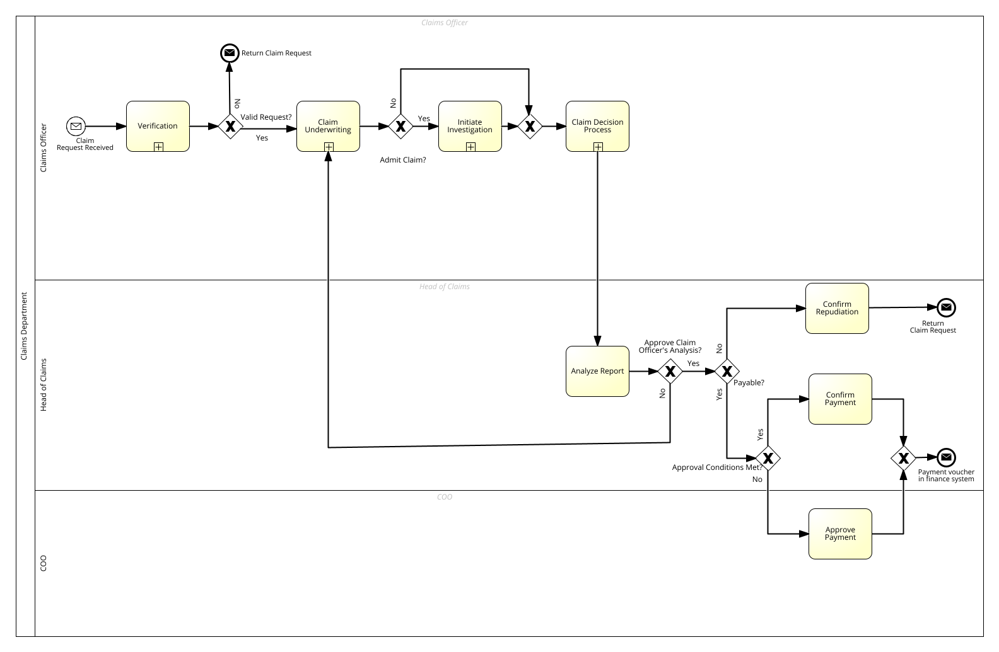

# OBSERVED PAIN POINTS & RISK AREAS

A number of recurring challenges were observed during the review of the current claims process. These do not represent the result of a detailed analysis, but rather key operational issues noted through close observation of daily practices and process flows. Importantly, these challenges do not stem from staffing or budget limitations. The most notable issues include:

* **Possible Delays in Investigations:** The investigation stage frequently contributes to the longest delays. These delays appear to be linked to the difficulties in confirming claim event. Claim officer or professional investigators physically visits the insured home to confirm the event. and the lack of clearly defined timelines for completing investigations.
* **Incomplete Applications Submissions:** Claims are often submitted without all the necessary supporting documents. This leads to repeated follow-up interactions between claimants and staff, resulting in possible extended processing times.
* **Limited Communication with Claimants :** Claimants typically receive limited updates on the progress of their claims. This lack of proactive communication may results in frustration and repeated follow-up enquiries from customers.These challenges were observed during the documentation of the AS-IS process and suggest that structural improvements, rather than increased staffing or budget, may be required to enhance speed, consistency, and customer experience.

# AS-IS PROCESS ANALYSIS

The AS-IS process was analyzed using established Business Process Management (BPM) techniques, with a particular focus on identifying inefficiencies, bottlenecks, and operational risks. The objective was to evaluate the current process using BPMN tools and methodologies to uncover value contributions and improvement opportunities, particularly within structurally constrained but not resource-constrained environments.

The analysis was divided into two main parts: qualitative analysis and quantitative analysis.

## Qualitative Analysis

The qualitative analysis utilized two key BPM techniques: Value-Added Analysis and the development of a risk-focused Issue Register. These methods helped classify the usefulness of process activities and highlight structural pain points.

### Value-Added Analysis (VA, BVA, NVA Classification)

Each step in the AS-IS process was categorized based on how it contributed to the clients’ experiences:

* **Value-Adding (VA):** Activities that directly contribute to the client’s benefit or satisfaction.
* **Business Value-Adding (BVA):** Activities that are necessary for the organization’s operations but may not be perceived as valuable by the customer.
* **Non-Value-Adding (NVA):** Activities that do not add value to either the client or the business, and which should be eliminated or automated where possible.

This classification revealed a number of **BVA** and **NVA** steps, particularly those involving repetitive manual verifications and approvals. Details are in the table below.

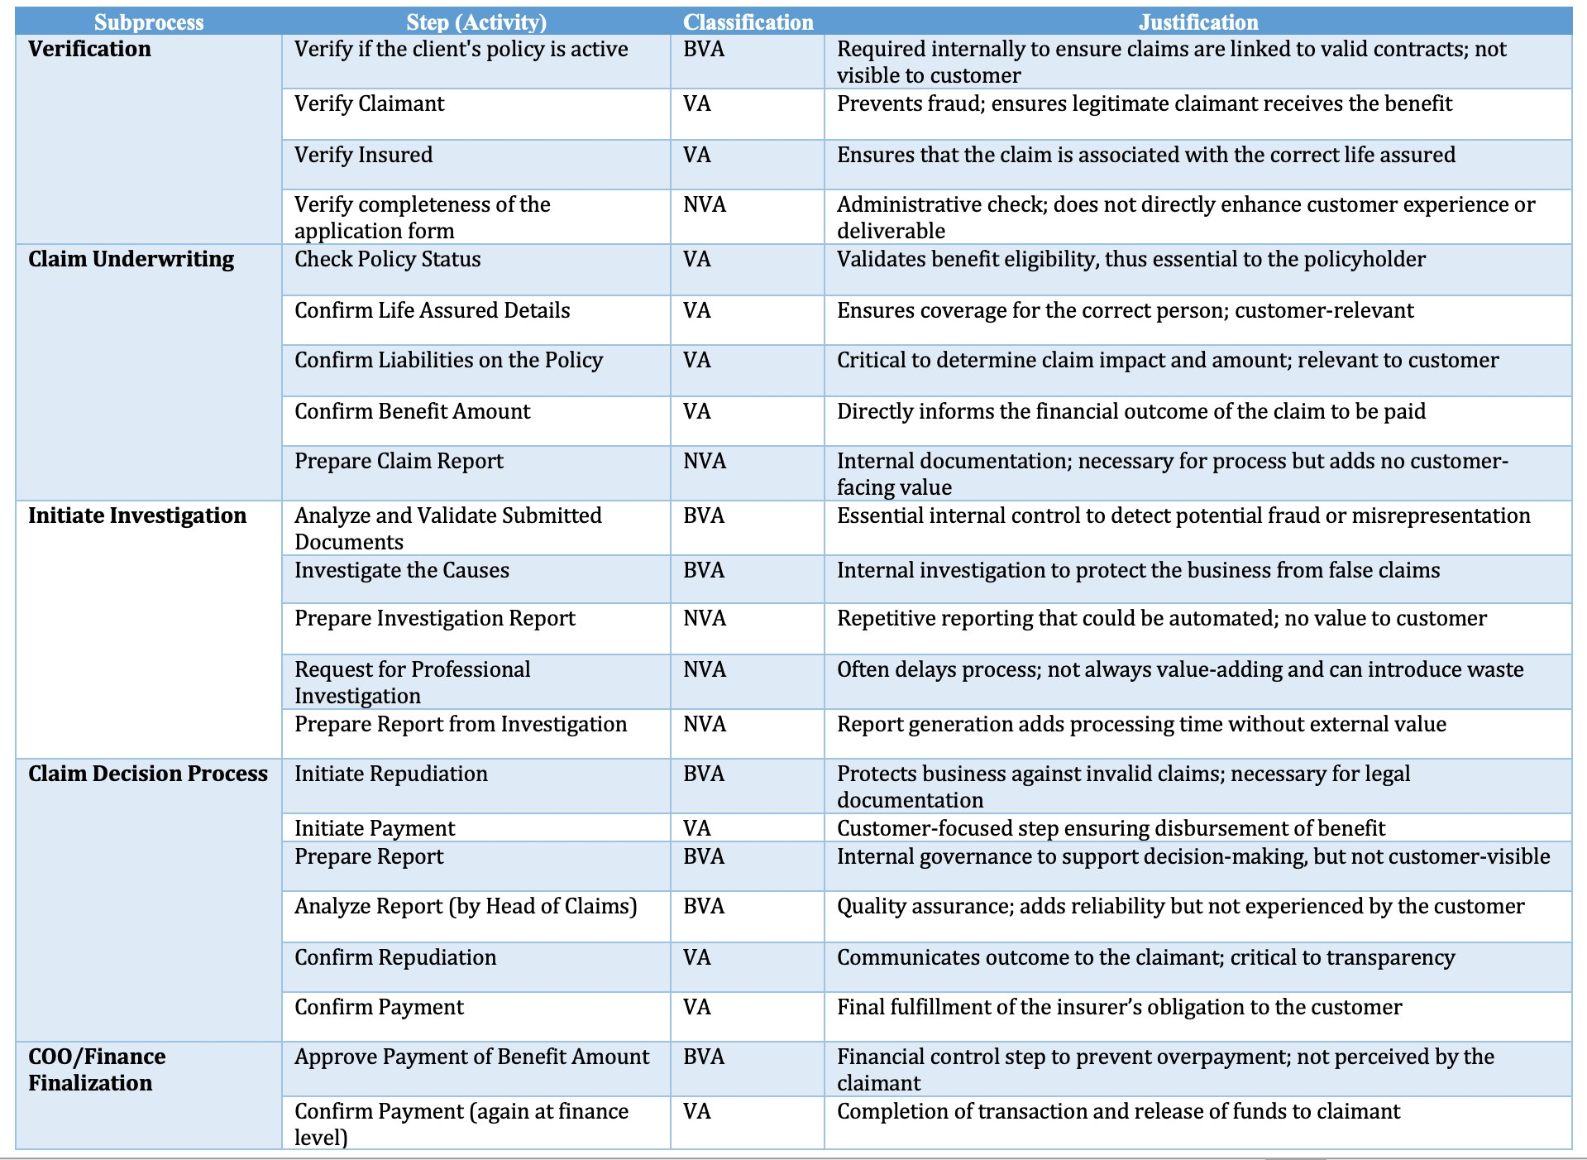

This analysis reveals that the largest portion of the process steps (39.1%) directly serve the claimant or insured, which is a positive indication of customer-centricity. However, a significant 34.8% of steps are classified as Business Value-Add (BVA) activities, mainly involving fraud checks and hierarchical approvals. While these are necessary, they present valuable opportunities for streamlining through intelligent automation. Notably, 26.1% of the steps fall under Non-Value-Add (NVA) activities, highlighting clear inefficiencies such as repetitive documentation preparation and duplicated investigation or reporting tasks. Overall, a greater proportion of the process (60.9%) does not directly serve the customer’s interest, suggesting a strong case for automating several steps to enhance efficiency and reduce waste.

### Issue Register (Operational Pain Points)

A structured Issue Register was developed to document recurring pain points observed in the process analysis

|  |  |  |  |
| --- | --- | --- | --- |
| Issue | Priority | Description | Potential Risk |
| Incomplete claim request | Medium | Claims are submitted without the necessary IDs or medical reports | Triggers reprocesses, an avoidable loop that can lead to prolong claim settlement |
| Policy Status Disputes | High | Customers are unaware of their policies are inactive due to lapsations. | Can lead to higher repudiation rate which can lead to reputational risk. |
| Delayed Investigations | High | Investigations | Prolonged claim resolutions can erode trust. |

These issues point to a lack of proactive customers communication, fragmented data a and manual handoffs that could be optimized through digital processes and customer self-service tools.

## Quantitative Analysis

To complement the qualitative findings, a discrete-event simulation was conducted using SAP Signavio Process Manager. The goal was to quantify inefficiencies by simulating case flow, activity durations, resource usage, and the effects of probabilistic decision-making under realistic constraints.

### Simulation Assumptions.

The simulation was built on carefully structured assumptions to mirror the day-to-day operations of the branch-level claims department. These assumptions were grouped into four key areas;

1. Task Duration and Variability

Each task in the claims process was assigned both an average execution time and a variability margin to reflect real-world delays caused by differences in case complexity or completeness of documentation

* Verification takes approximately 4 minutes, with a ±1 minute variability.
* Claim Underwriting takes about 5 minutes, also with a ±1 minute variability.
* Initiate Investigation is a longer task, averaging 3 hours with a ±30-minute deviation.
* Claim Decision Process is faster, taking 2 minutes with a ±1 minute variation.
* Analyze Report, Confirm Repudiation, Confirm Payment, and Approve Payment each take around 2 minutes, all with ±1 minute variability.

2.Event Frequency and Case Arrival Rate

* Claims are assumed to arrive only on weekdays (Monday to Friday).
* The total case volume for the simulation period is 20 claims, reflecting a moderate and realistic load at the branch level of a small insurer.

3. Process Logic and Decision Probabilities

To simulate real decision-making behavior, probabilities were assigned to each conditional gateway in the process:

* For the "Valid Request?" check, 90% of claims are considered valid, and 10% invalid.
* In the "Officer’s Analysis Approved?" stage, there’s a 95% chance of approval and 5% of rejection.
* The "Is Claim Payable?" decision assumes a 95% chance that claims are payable, and 5% are not.
* In the "Approval Conditions Met?" check, 95% of claims meet conditions, while 5% do not.

4. Human Resources and Cost Assumptions

The simulation includes three types of human resources, each with specified working hours, staff numbers, and hourly cost rates:

* Claims Officers: 4 staff members, each working 160 hours per week, with an hourly rate of GHC20.
* Head of Claims: 1 staff member, working 40 hours per week, at GHC50 per hour.
* Chief Operating Officers (COO): 2 staff members, each working 40 hours per week, at GHC70 per hour.

### Simulation Configuration

The simulation was configured in SAP Signavio Process Manager using a fully parameterized BPMN model. Task nodes, decision gateways, and resource pools were accurately defined in line with the assumptions described above.

### Simulation Parameters:

* Tool: SAP Signavio Process Intelligence
* Period: 1 workweek (Monday to Friday)
* Case Arrival Rate: Uniform, 20 claims total
* Simulation Type: Deterministic with stochastic task-time deviations
* Tracked Outputs: Average case duration, bottleneck frequency, resource workload, and cost metrics

## Key Results of the AS-IS Claim Process

The AS-IS simulation of the claims processing workflow provides valuable insights into the operational performance, cost structure, resource utilization, and bottlenecks within the current system. The analysis spans multiple dimensions, including cycle times, execution costs, and resource workloads, offering a holistic view of the process efficiency.

Detailed simulation result is found here: 

Overall Process Performance

**Cycle Time:**

* The total cycle time for the process was approximately 5.33 days, with an average instance duration of 0.27 days. The fastest instance completed in 0.0017 days, while the slowest took 1.11 days.

|  |  |  |  |  |  |  |
| --- | --- | --- | --- | --- | --- | --- |
|  | Duration in days | Completed instances | Average | Minimum | Maximum | Total execution time |
| Verification | 5 | 20 | 0h:03m 45s | 0h:02m 08s | 0h:04m 58s | 1h:15m 19s |
| Claim Underwriting | 5 | 20 | 0h:04m 59s | 0h:02m 30s | 0h:06m 10s | 1h:39m 56s |
| Initiate Investigation | 5 | 18 | 6h:49m 46s | 2h:01m 37s | 20h:05m 21s | 122h:56m 02s |
| Claim Decision Process | 5 | 20 | 0h:02m 09s | 0h:00m 05s | 0h:05m 28s | 0h:43m 05s |
| Analyze Report | 5 | 20 | 0h:02m 13s | 0h:00m 58s | 0h:04m 05s | 0h:44m 30s |
| Confirm Repudiation | 5 | 2 | 0h:01m 14s | 0h:00m 46s | 0h:01m 42s | 0h:02m 28s |
| Confirm Payment | 5 | 14 | 0h:02m 09s | 0h:00m 10s | 0h:03m 53s | 0h:30m 13s |
| Approve Payment | 5 | 2 | 0h:01m 19s | 0h:01m 13s | 0h:01m 25s | 0h:02m 38s |

**Resource Consumption:**

* The process involved 4 Claims Officers, with a total resource consumption of 2.66 days. These Claims Officer role accounted for the majority of workload (approx. 0.41), followed by the Head of Claims and COO with significantly lower workloads.

### Cost Analysis

**Total Cost:**

* The overall cost associated in processing the 20 submitted claims was GHC1,318.85, with individual instance costs ranging from GHC0.82 to GHC214.58.

|  |  |  |  |  |  |
| --- | --- | --- | --- | --- | --- |
|  | Completed instances | Average | Minimum | Maximum | Total costs |
| Verification | 20 | GHC 1.26 | GHC 0.71 | GHC 1.66 | GHC 25.11 |
| Claim Underwriting | 20 | GHC 1.67 | GHC 0.83 | GHC 2.06 | GHC 33.31 |
| Initiate Investigation | 18 | GHC 65.48 | GHC 40.54 | GHC 81.78 | GHC 1'178.68 |
| Claim Decision Process | 20 | GHC 0.72 | GHC 0.03 | GHC 1.82 | GHC 14.36 |
| Analyze Report | 20 | GHC 1.85 | GHC 0.81 | GHC 3.40 | GHC 37.08 |
| Confirm Repudiation | 2 | GHC 1.03 | GHC 0.64 | GHC 1.42 | GHC 2.06 |
| Confirm Payment | 14 | GHC 1.80 | GHC 0.14 | GHC 3.24 | GHC 25.18 |
| Approve Payment | 2 | GHC 1.54 | GHC 1.42 | GHC 1.65 | GHC 3.07 |

**Cost by Activity:**

* Initiate Investigation was the most expensive task, contributing GHC1,178.68 to the total cost.
* Other notable cost contributors include Claim Underwriting (GHC33.31), Analyze Report (GHC37.08), and Confirm Payment (GHC25.18).
* Activities like Confirm Repudiation and Approve Payment had minimal cost impact.

### Execution Time Analysis

**Execution Times Including Waiting:**

* The longest execution time was for Initiate Investigation, averaging 0.28 days per instance.
* Other tasks had significantly shorter durations, typically under 0.005 days.

**Pure Execution Times:**

* These exclude waiting times and show that Initiate Investigation still dominates with 2.46 days total execution time.
* All other activities had execution times under 0.07 days, indicating efficient task handling when resources are available.

### Resource Utilization

**Claims Officer:**

* Consumed 2.61 days of time, indicating high involvement and potential for overload.

**Head of Claims:**

* Used 0.0536 days, suggesting a more supervisory role.

**COO:**

* Minimal involvement with 0.0018 days consumed.

Bottlenecks and Process Insights

* The Initiate Investigation task is a clear bottleneck due to its high cost and long duration.
* Despite high frequency, tasks like Verification and Claim Underwriting are efficiently executed with low cost and time.
* The process is highly dependent on Claims Officers, highlighting a need for workload balancing or automation in high-frequency tasks.

# REDESIGNING

To transition from the AS-IS claims process to a more efficient and customer-centric TO-BE model, a structured redesign strategy was implemented. This involved applying a series of established Business Process Redesign (BPR) heuristics, each targeting specific inefficiencies identified during the earlier analysis phase.

The redesign objectives included:

* Reducing investigation cycle times.
* Eliminating non-value-adding activities and minimizing business-valued activities.
* Balancing workloads across staff roles.
* Automating some core tasks.
* Enhancing communication with claimants.
* Implementing a centralized Claims Management System (CMS).

Each redesign heuristic addressed particular structural or operational process weaknesses within the AS-IS, offering actionable changes aimed at realizing measurable improvements.

## Task Elimination (Heuristic 1)

The AS-IS process contained several redundant manual steps, particularly during document verification and approval. These included:

* Manual checks for document completeness.
* Duplicated report approvals by both the Head of Claims and the Chief Operating Officer (COO) for all claims including low-value claims.

These non-value-adding tasks were eliminated by introducing automated validation mechanisms within the new CMS. Low-value claims now bypass unnecessary layers of approval. These changes are expected to streamline workflow, reduce delays, and lower operational overhead.

## Task Composition and Decomposition (Heuristic 2)

To address process fragmentation, two complementary strategies were applied:

* Task Composition:
  + Related verification tasks, including identity checks, policy validation, and completeness assessments, were merged into a single automated verification module within the CMS.
* Task Decomposition:
  + Complex investigative tasks were split into two parts: A routine, automated component for standard validation A manual component for exceptional cases requiring escalation.

This dual approach minimizes context switching, clarifies task ownership, and enhances compatibility with automation technologies.

## Triage (Heuristic 3)

Previously, all claims followed a uniform workflow regardless of complexity or value. A triage mechanism will be introduced to classify and route claims based on pre-defined criteria:

* Low-value claims (below the free medical limit) are automatically fast-tracked.
* High-value or high-risk claims are routed for manual evaluation.

This differentiation enables quicker resolution of straightforward cases while ensuring that complex claims receive the necessary scrutiny.

## Re-sequencing (Heuristic 4)

To avoid expending resources on invalid or non-payable claims, key validation steps were moved earlier in the process:

* Automated ID and policy checks now occur immediately after claim submission.
* Investigations are deferred until these preliminary checks are passed.

This approach increases early rejection efficiency and reduces wasted effort on ineligible claims.

## Parallelism Enhancement (Heuristic 5)

The current claims process was largely sequential, contributing to long cycle times. Under the TO-BE model:

* Underwriting and document verification tasks are performed concurrently
* Communication with the claimant occurs in parallel with internal assessments

This redesign allows multiple process streams to advance simultaneously, significantly reducing the total turnaround time.

## Process Specialization (Heuristic 6)

The Current “one-size-fits-all” approach was replaced with specialized process paths based on claim type. For example:

* Claims exceeding the medical benefit limit now follow a tailored workflow
* Each pathway reflects the unique data requirements and decision criteria relevant to that claim category.

This specialization improves efficiency and accuracy by reducing irrelevant checks and tasks.

## Resource Optimization (Heuristic 7)

Under the AS-IS model, Claims Officers were responsible for approximately 98% of process tasks, creating workload imbalances. The redesigned model redistributes responsibilities using the CMS:

* Tasks are dynamically assigned based on staff availability and expertise.
* Workloads are more evenly shared among Claims Officers and the Head of Claims. COO was eliminated from the process.

This reduces individual staff burnout and enhances overall decision quality.

## Communication Optimization (Heuristic 8)

To address poor claimant communication, the TO-BE model incorporates several enhancements:

* Real-time SMS and email notifications are sent at key process milestones.
* A secure claimant portal allows users to track claim status and upload documents.

These improvements are expected to reduce the volume of inbound inquiries and enhance the customer experience.

## Automation (Heuristic 9)

A major pillar of the TO-BE process is automation. Several previously manual tasks have now been automated:

* ID and policy validation.
* Underwriting checks.
* Payment voucher generation.

The new CMS integrates with external databases, including:

* The National Identification Authority.
* Ghana Police Service.
* Ghana Health Service.
* The Birth and Death Registry.

# Overview of the TO-BE Claims Process

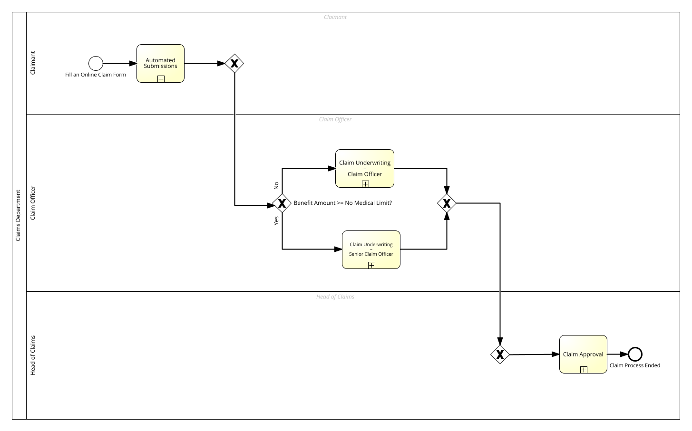

The redesigned TO-BE claims process was developed to address the inefficiencies and pain points identified in the AS-IS model. The primary goals of the transformation were to reduce overall cycle time, eliminate non-value-adding activities, balance workloads across roles, and improve both automation and claimant communication.

At the heart of the TO-BE model is a Claims Management System (CMS), which integrates with multiple national and institutional databases. The CMS supports claims officers by providing real-time access to external data, enabling automated validation, task allocation, and workflow tracking. The process now consists of three core stages: Automated Submission, Claims Underwriting, and Approval.

## Automated Submission

The first step in the TO-BE process is a fully automated submission via a digital portal accessible through the company’s website. This portal is built on the CMS infrastructure and performs the following functions:

* Document Validation: Submitted claims must include all relevant documents. The CMS validates these in real time. If the documents are incomplete or unverifiable, the submission is automatically rejected, preventing unnecessary processing.
* Policy Verification: The portal checks policy details such as policy number, coverage, and validity using integrated data from the company’s policy database.
* Skill-Based Claim Routing: Based on the nature and value of the claim, the system assigns each submission to the appropriate officer:Claims equal to or exceeding the free medical limit are routed to senior claims officers.All other simpler claims are assigned to claims officers for handling.This intelligent allocation ensures efficient processing and proper alignment of claim complexity with officer expertise.

This stage reduces human intervention, accelerates verification, and ensures claims are triaged effectively at the point of entry.

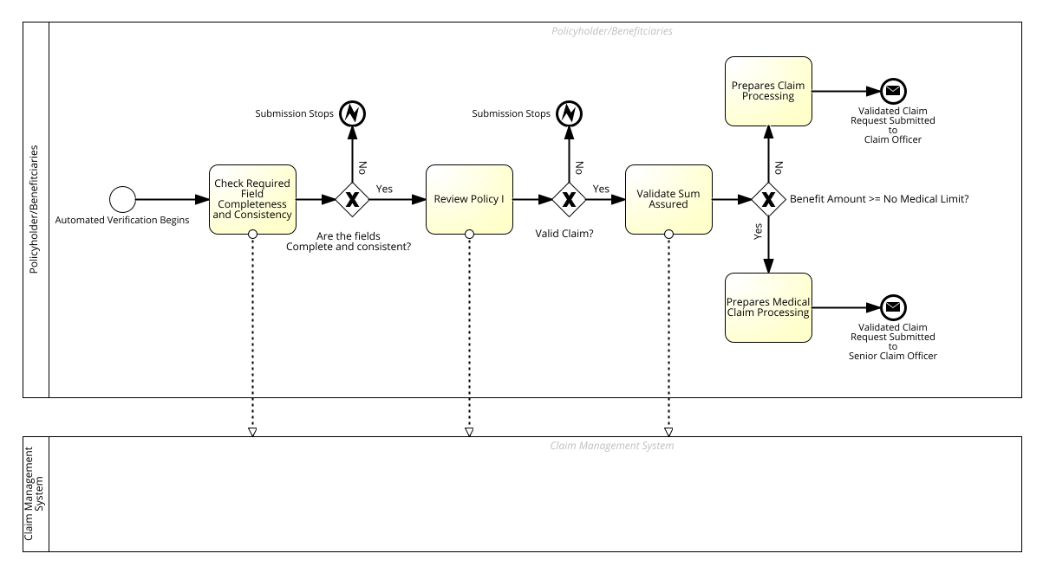

## Claims Underwriting

Once assigned, the designated claims officer initiates underwriting using the CMS, which provides secure access to multiple external data sources. The process includes:

* Cross-Verification: Officers verify the validity of submitted claims by checking relevant supporting documentation against institutional databases. For example:In the case of an accident claim, officers can verify police reports or medical records through integrations with the Ghana Police and Ghana Health Service databases.
* Complex Case Handling:Senior claims officers handle complex, high-value, or escalated cases based on predefined thresholds and triage rules.
* Underwriting Report: After validating the claim, the officer compiles an underwriting report that includes:Confirmation of claim validitySupporting evidenceA recommendation for approval or repudiation

The claimant receives an automatic notification informing them whether their claim is under review, conditionally accepted, or provisionally repudiated, depending on the CMS decision logic and officer assessment.

Claim Officer’s Underwriting

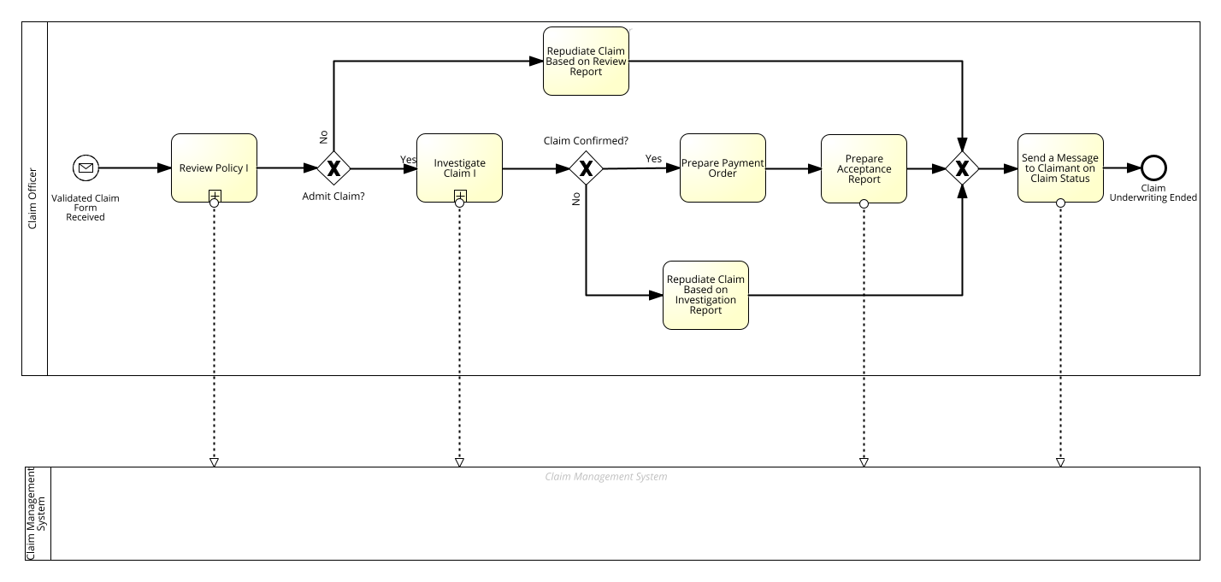

Senior Claim Officer’s Underwriting

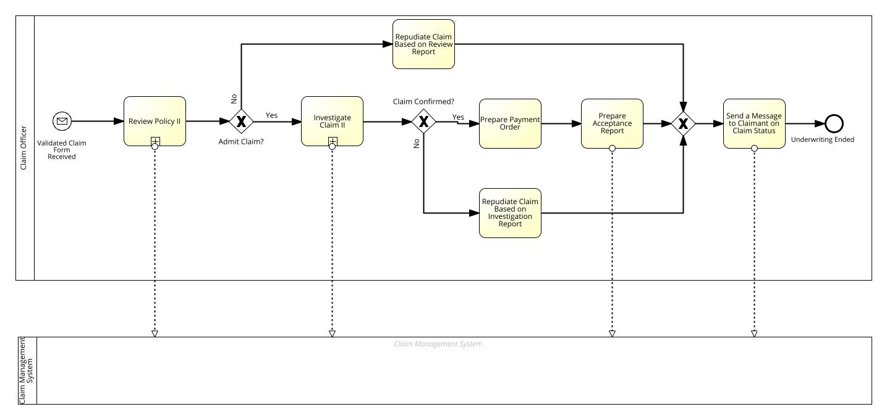

## Approval

The final stage involves decision-making and authorization:

* Review by Head of Claims:The underwriting report is forwarded to the Head of Department (HoD) for final review.If the HoD identifies inconsistencies or unclear justifications, the report is sent back to the senior claim officer to underwrite again, regardless of case complexity.
* Final Decision and Action:Once satisfied, the HoD either authorizes payment or repudiates the claim.For approved claims, instructions are sent to the finance team for disbursement. The claimant is automatically notified of the outcome, approval or repudiation, through the CMS via SMS or email.

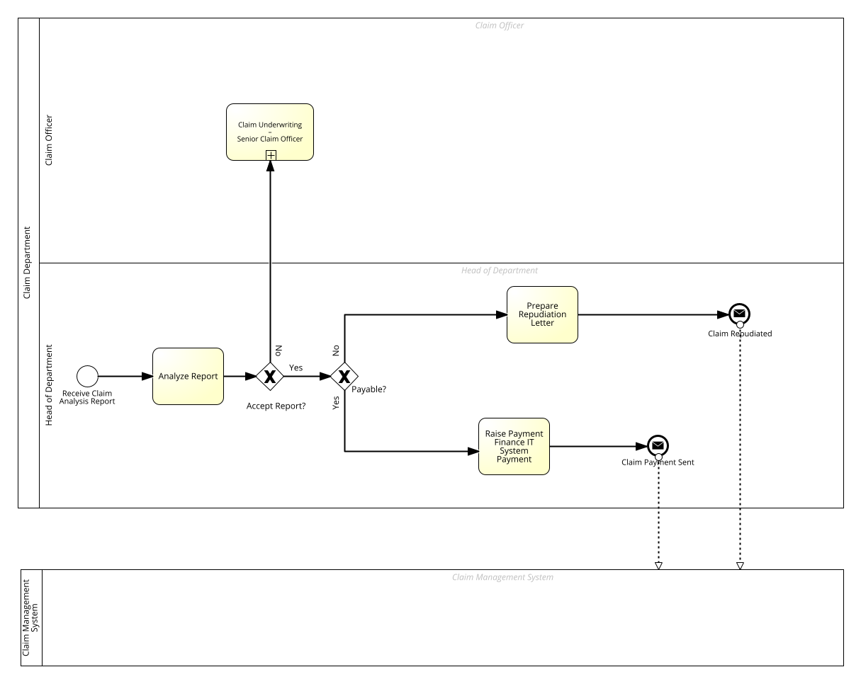

This streamlined approval process, supported by automation and system integration, ensures accuracy, transparency, and a reduced administrative burden on decision-makers.

# ANALYSIS OF THE TO-BE MODEL

## Assumption

To evaluate the impact of the redesigned TO-BE claims process, a targeted simulation was conducted under the resource-constrained conditions of a typical branch-level life insurer. The assumptions for this simulation reflect the improvements introduced through automation, task realignment, and workflow specialization, and are structured across four key dimensions: task durations, process logic probabilities, resource modeling, and system automation.

### Task Duration and Execution Assumptions

In the redesigned TO-BE process, task durations have been optimized due to automation and streamlined workflows. Manual bottlenecks from the AS-IS process have been replaced or minimized.

* Automated Submissions are completed in an average of 3 minutes, with a ±1-minute deviation.
* Claim Underwriting (Claim Officer) takes an average of 5 minutes, with ±1-minute deviation.
* Claim Underwriting (Senior Claim Officer) involves more complex cases and requires about 10 minutes, with ±2-minute deviation.
* Claim Approval is performed in an average of 6 minutes, with a ±2-minute deviation.

Notably, all tasks are modeled with zero cost (GHC0.00) at this stage to isolate the effect of process logic and task sequence on performance without financial weighting.

### Decision Logic and Probabilities

Decision gateways in the TO-BE model reflect optimized logic for faster claim routing:

* A gateway condition, “Is Benefit Amount ≥ No Medical Limit?”, was introduced to triage claims automatically.
* The probability of this condition being “No” is 80%, which means the majority of claims bypass the additional review layer, enabling a high volume of claims to proceed through the faster, automated route.

This change introduces smart triaging directly into the CMS, reducing unnecessary manual review for straightforward claims.

### Resource Optimization

While specific resource costs were not assigned in this simulation run, the process assumes the availability of both Claim Officers and Senior Claim Officers, reflecting task specialization introduced in the TO-BE design. The automated task handling assumes limited human interaction for low-value claims, reserving higher complexity tasks for more experienced staff.

### Inclusion of Claim Management System (CMS)

A Claims Management System (CMS) is proposed as the cornerstone of the TO-BE process. The CMS integrates with all process activities, automates some core tasks, connects to relevant national databases, allocates workloads, and provides real-time claimant updates. This document elaborates on the CMS features, outlines the TO-BE process, and provides a textual BPMN diagram for implementation.

#### Some Features of the Claims Management System

The CMS is designed to streamline the claims process by embedding automation, data integration, workload management, and claimant communication into every activity. Its key features are:

* End-to-End Process Integration:The CMS is embedded in all process stages, from claim submission to payment or rejection, ensuring seamless data flow and task coordination.Supports all activities (e.g., verification, triage, underwriting, investigation, decision-making) with automated modules and user interfaces for manual tasks.
* Automated Verification:Shifts manual verification tasks (e.g., identity checks, policy status) to automated modules, Validates document completeness (e.g., claim form, proof of event, IDs) using OCR and rule-based checks.Integrates with national databases:

1. Birth and Death Registry Database: Verifies deceased individuals’ details (name, date of death, national ID) for death claims.
2. Ghana Health Service Database: Provides data on deceased persons, accident victims, and accident types (e.g., road traffic, workplace), including national IDs, to validate medical or accident-related claims.
3. Ghana Police Service Database: Supplies data on deceased persons, accident victims, and accident details (e.g., cause, location), including national IDs, for claims involving accidents or unnatural deaths.
4. National Identification Authority (NIA) Database: Confirms claimant and insured identities using national ID data.

* Workload Allocation:Dynamically assigns tasks to Claims Officers based on claim complexity.
* Real-Time Claimant Communication:Sends automated SMS/email notifications at key stages (e.g., “Claim Received,” “Verified,” “Approved,” “Rejected”) and request for missing documents.
* System Automation:Automates core tasks beyond verification, including:

1. Submission Intake: Pre-validates documents via the online portal, flagging incomplete submissions in real-time.
2. Policy Checks: Verifies policy status (active, premiums paid) and coverage during underwriting using internal database queries.
3. Payment Processing: Generates payment vouchers for approved claims automatically.

# Key Results of the TO-BE Claim Process

|  |  |  |  |  |  |  |  |
| --- | --- | --- | --- | --- | --- | --- | --- |
|  | | Duration in days | Completed instances | Average | Minimum | Maximum | Total execution time |
| Automated Submissions | 5 | | 20 | 0h:02m 54s | 0h:00m 25s | 0h:04m 58s | 0h:57m 54s |
| Claim Underwriting – Claim Officer | 5 | | 16 | 0h:04m 55s | 0h:02m 30s | 0h:06m 57s | 1h:18m 35s |
| Claim Underwriting – Senior Claim Officer | 5 | | 4 | 0h:08m 57s | 0h:07m 34s | 0h:10m 56s | 0h:35m 47s |
| Claim Approval | 5 | | 20 | 0h:05m 48s | 0h:00m 51s | 0h:09m 56s | 1h:55m 52s |

The TO-BE simulation presents a reimagined version of the claims processing workflow, incorporating automation and streamlined decision-making. This chapter outlines the key performance indicators, cost efficiencies, and resource utilization improvements observed in the redesigned process.

Detailed Result Here: 

## Overall Process Performance

**Cycle Time:**

* The total cycle time was significantly reduced to 0.20 days (4hrs, 48 min.), with an average instance duration of just 0.01 days. This marks a dramatic improvement over the AS-IS process, which averaged over 5 days.

**Resource Consumption:**

* The total resource consumption matched the cycle time at 0.20 days, indicating a highly efficient and synchronized process flow.

## Cost Analysis

**Total Cost:**

* The overall cost of the TO-BE process was GHC221.30, a substantial reduction from the AS-IS cost of GHC1,318.85.

**Cost by Activity:**

* Claim Approval was the most expensive activity at GHC115.87, reflecting its critical role in the process.
* Automated Submissions and Claim Underwriting – Claim Officer followed with GHC48.25 and GHC39.29, respectively.
* Claim Underwriting – Senior Claim Officer had the lowest cost at GHC17.89, due to fewer instances requiring escalation.

## Execution Time Analysis

Execution Times Including Waiting:

* All activities were completed in under 0.01 days on average.
* Automated Submissions had the shortest average execution time at 0.002 days, highlighting the impact of automation.

Pure Execution Times:

* The values closely mirrored the inclusive times, indicating minimal waiting or delay.
* Claim Approval remained the longest task, but still executed in under 0.01 days.

## Resource Utilization

* Head of Claims: Consumed 0.08 days with a workload of 40%.
* Claim Officers: Also consumed 0.08 days and a 40% workload.
* Claimant: Participated in Automated Submissions, consuming 0.04 days and a 20% workload. The claimants are essential part of the claim management team, hence their inclusion in the workload.

## Bottlenecks and Process Insights

The TO-BE process eliminated traditional bottlenecks by:

* Introducing automated submissions, reducing manual intake time.
* Streamlining underwriting with clear escalation paths.
* Maintaining a high degree of parallelism and minimal waiting times.
* The process is now leaner, faster, and more cost-effective, with automation playing a pivotal role in reducing human workload and accelerating throughput.

# Comparison: TO-BE vs AS-IS

## Automation

The TO-BE process introduces automated verification and submission, significantly reducing manual intervention. This automation streamlines the intake phase, ensuring faster and more accurate data capture. In contrast, the AS-IS process relied heavily on manual document validation and routing, which was time-consuming and prone to delays and errors.

## Workload Distribution

In the TO-BE model, tasks are more evenly distributed among the Claim Officer, Head of Claims, and CMS, promoting better resource utilization and reducing individual overload. The AS-IS process, however, placed approximately 98% of the workload on Claim Officers, creating bottlenecks and inefficiencies.

## Claimant Experience

The TO-BE process enhances the claimant experience by including them in the process and offering them a real-time updates to track the claim status. This transparency fosters trust and reduces the need for follow-up inquiries. The AS-IS process lacked such communication touchpoints, leaving claimants in the dark about their claim progress.

## Decision Efficiency

Using triage logic, the TO-BE process intelligently routes claims based on their value and complexity, ensuring that simpler cases are resolved quickly while more complex ones receive appropriate attention. The AS-IS model applied a uniform approach to all claims, regardless of complexity, leading to inefficiencies and slower resolutions.

## Process Transparency

The TO-BE process includes real-time logging and performance tracking, enabling continuous monitoring and improvement. This level of visibility was absent in the AS-IS process, which lacked centralized tracking and analytics capabilities.

|  |  |  |  |
| --- | --- | --- | --- |
| Metric | AS-IS Process | TO-BE Process | Improvement |
| Avg Cycle Time/Case | 0.27 days (~6.5 hrs) | 0.01 days (~14 min) | 96% faster |
| Total Cycle Time (20 cases) | 5.33 days | 0.20 days | 5.13 days saved |
| Avg Cost/Case | GHC65.94 | GHC11.06 | 83% cheaper |
| Total Cost (20 cases) | GHC1,318.85 | GHC221.30 | GHC1,097.55 saved |
| Claims Officer Workload | 40.91% | 4.98% | 88% reduction |

The TO-BE claim process delivers significant operational gains across multiple dimensions. It reduces the average case cycle time by an impressive 96%, saving over five days in total for every 20 cases processed. This acceleration is matched by a sharp drop in costs, with the average cost per case falling by 84%, making the process far more economical for high-volume operations. Additionally, the workload on Claims Officers is reduced by 88%, freeing up valuable staff capacity for other strategic or customer-focused tasks. Collectively, these improvements result in a claims process that is faster, more cost-effective, and considerably less labor-intensive.

# CONCLUSION

The TO-BE process delivers dramatic improvements in speed, cost, and efficiency. By applying redesign heuristics such as automation, triage, task elimination, and resource optimization, the claims department transitions from a manual, bottlenecked workflow to a streamlined, intelligent system.